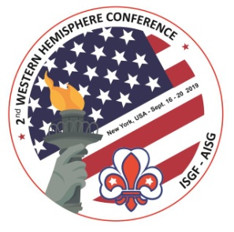 | 2nd Western Hemisphere  Region Conference  16 – 20 September 2019, New York, USA  2ème Conférence Région  Hémisphère Occidental | 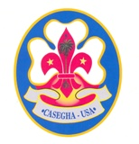

REGISTRATION FORM
Please fill one form per person

- Personal information

Family name:

First name: M/F

Postal address:
City: Post code: Country:

Telephone number:

Email address:

Name of your NSGF/CB:

Position in Fellowship:

Languages spoken: ꙱ English ꙱ French ꙱ Spanish

Special requests re diet/mobility or other:

Person to be notified in case of emergency:

Name:
Address: Country:
Telephone number:
Email address:

- Hotel accommodation
IBIS STYLES HOTEL
Double room only.

I wish to share the room with:

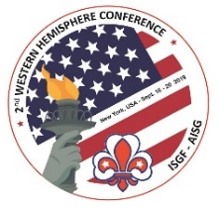

Nr. of nights: Check in date: Check out date:
Date Extra night(s):
Costs Extra Night before Conference is $227.26 per room. (Incl. tax. No breakfast incl.)

After the Conference (from Sept. 20-24): Hotel will offer 15% discount off the BAR Rate.
(no breakfast incl.)
Date Extra night(s):

- Post conference tours

꙱ Tour 1: Washington DC, Philadelphia and New York City: three-day tour (September 20 to 22, 2019) $578 per person/double occupancy – add $140 for single supplement; minus $40 per person, 3 or 4 in a room (2 double beds in room) – Deposit $75 p/p due upon reservation; balance due on July 21, 2019

꙱ Tour 2: Niagara Falls: three-day tour (September 20 to 22, 2019) $687 per person/double occupancy; single: add $276 p/p. Valid passport with Canadian visa.

꙱ Tour 3: New York City: two-day tour (September 20 and 21, 2019): 1st Day, Visit of Statue of Liberty Express Cruise, One World Trade Observatory, 9/11 Memorial, Times Square.
2nd Day: Bus Tour by Metropolitan Shuttle, Harlem and Museum of Natural History, Lunch Broadway Show. Total price: $350.00

Tours will be organized provided there are 30 or more participants.

- Cancellation policy
If your reservation is cancelled before 18th August 2019: 50% refund
If your reservation is cancelled after 18th August 2019: no refund

- Payment details
Registration Fee: $650.00 p/p from 16-20 September 2019. Includes: hotel (4 nights), transportation, continental breakfasts, coffee breaks, lunches, welcome and farewell dinners and dinner-cruise.

A non-refundable registration fee of USD 300 per person + processing fee USD 10 ($310) must be remitted to our account at:
CITIBANK
Account name: Association des Anciens Scouts et Guides d’Haïti
Account number: #23532544
Routing #: 021000089
Swift Code: Citi US 33

Remittances to be made without costs to the receiver

Pre-registration period until 30th April, 2019.

Full amount must be remitted before 30th July 2019.

Registration forms for participation in the conference to be sent by e-mail to
Lyssa H. Dallemand (International Secretary via lysou6@aol.com)

