
11th Europe Conference
11e Conférence Européenne
Ranum, Denmark 30 July – 3 August 2023

Document 4

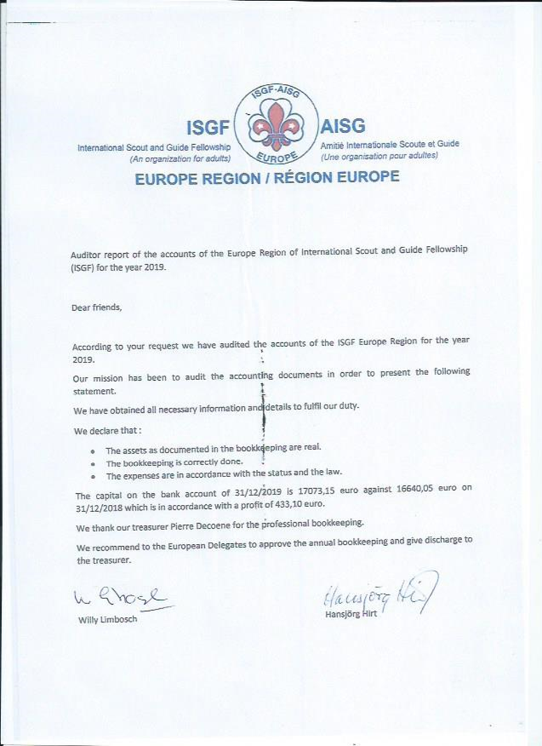
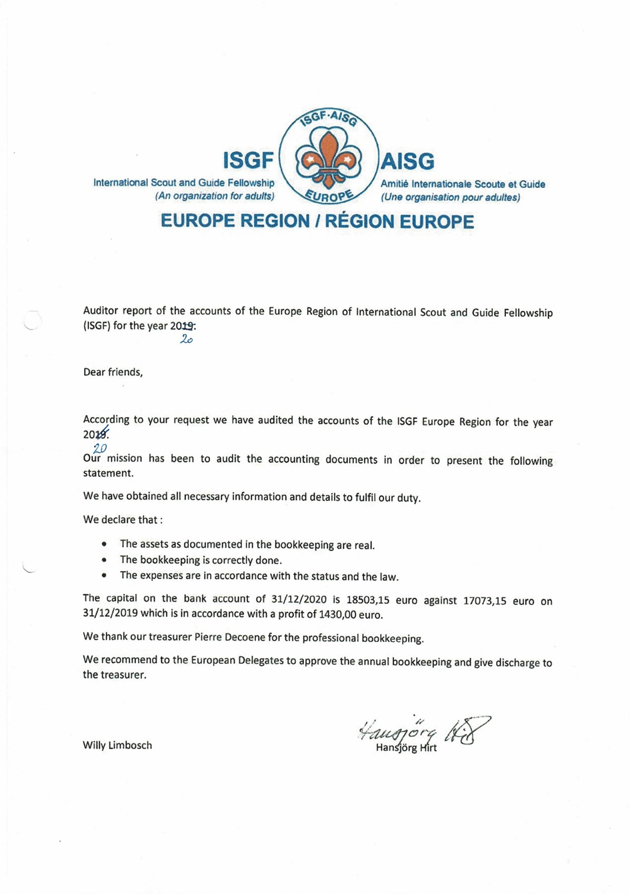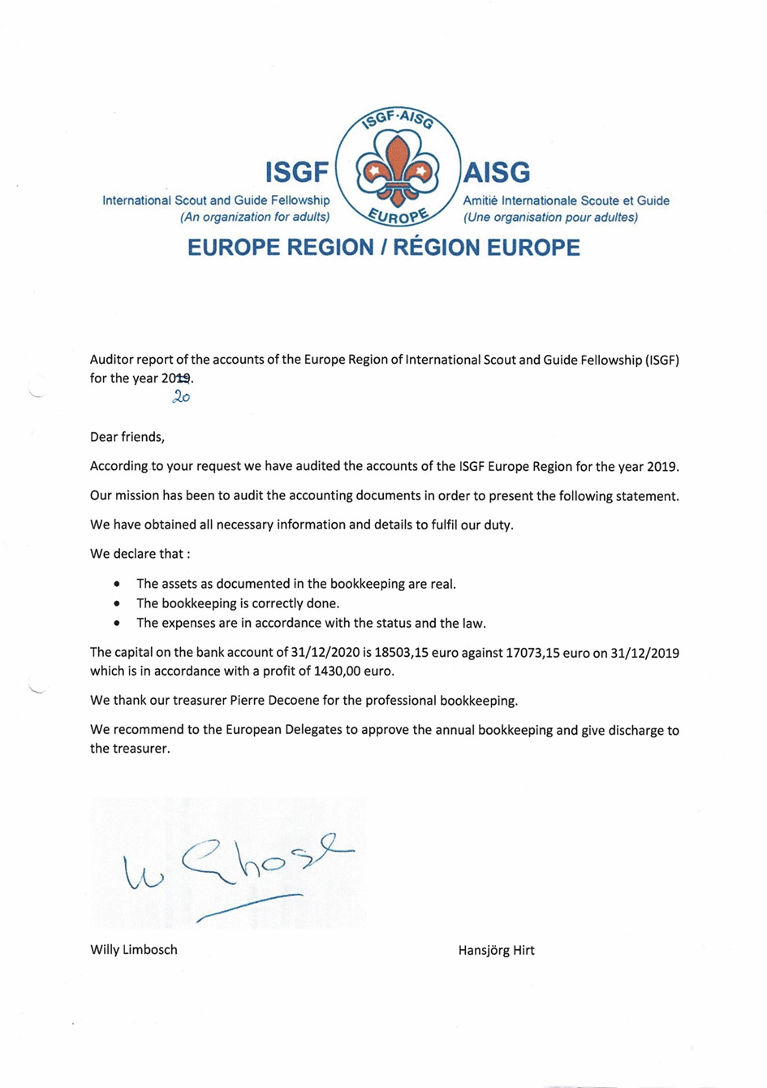
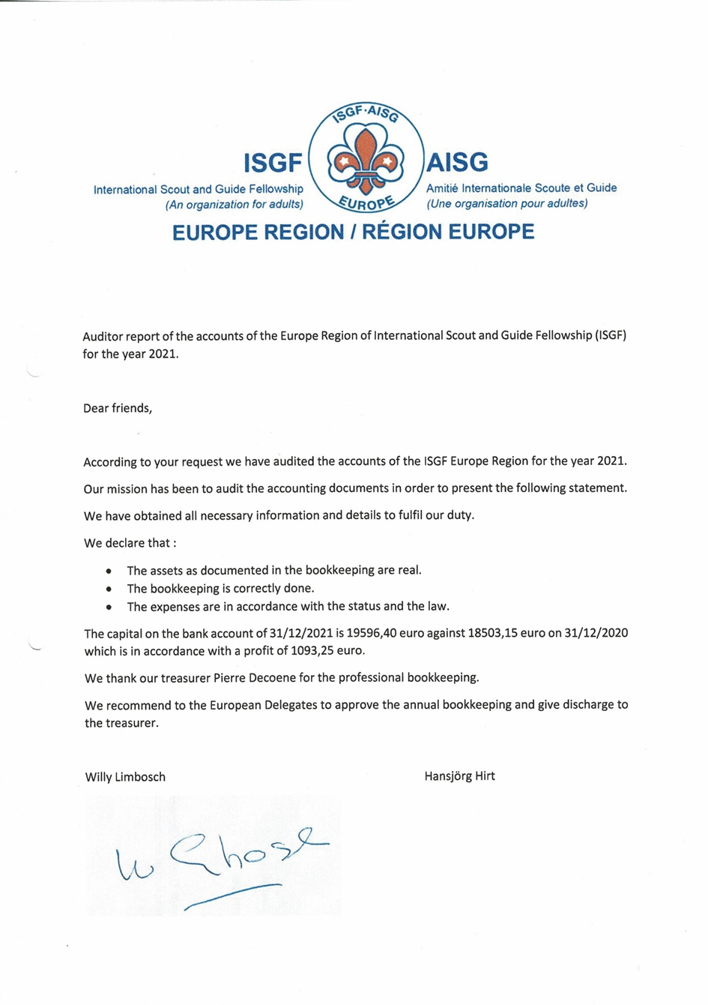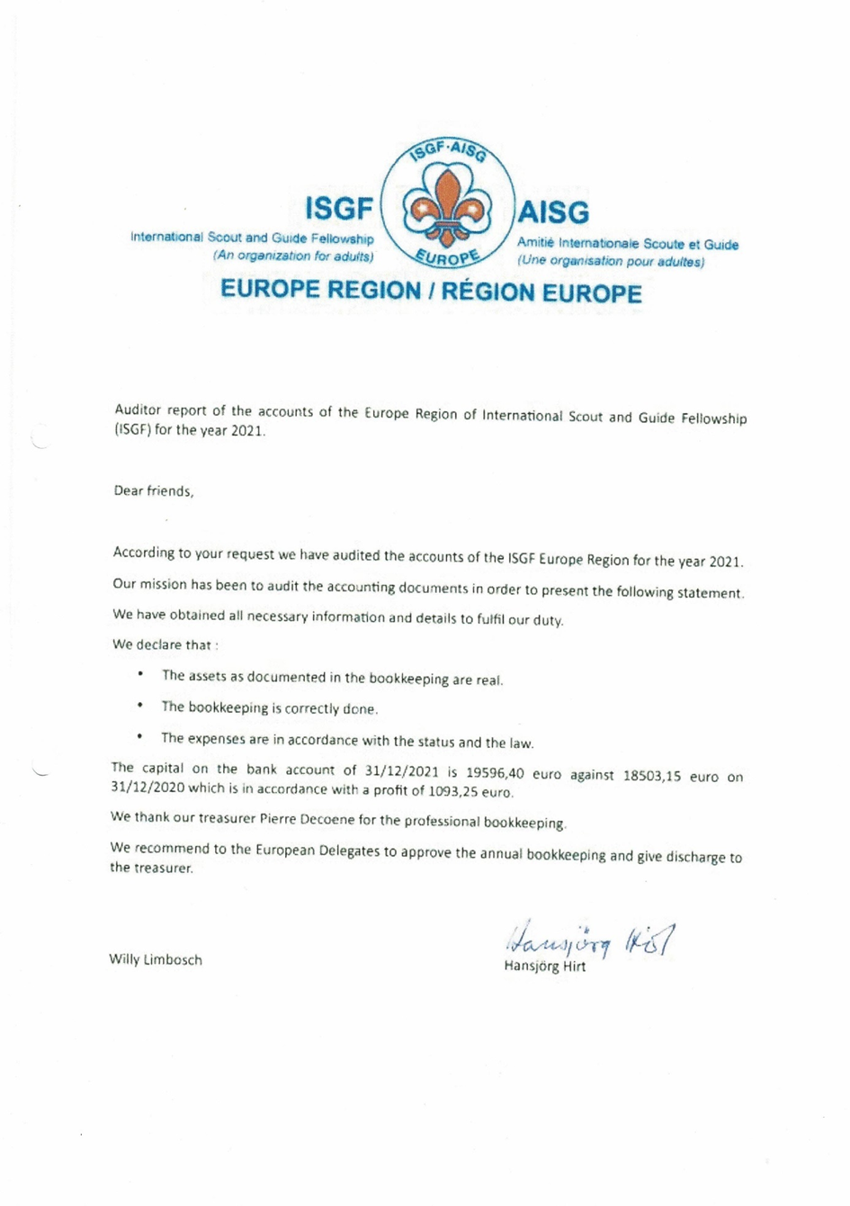

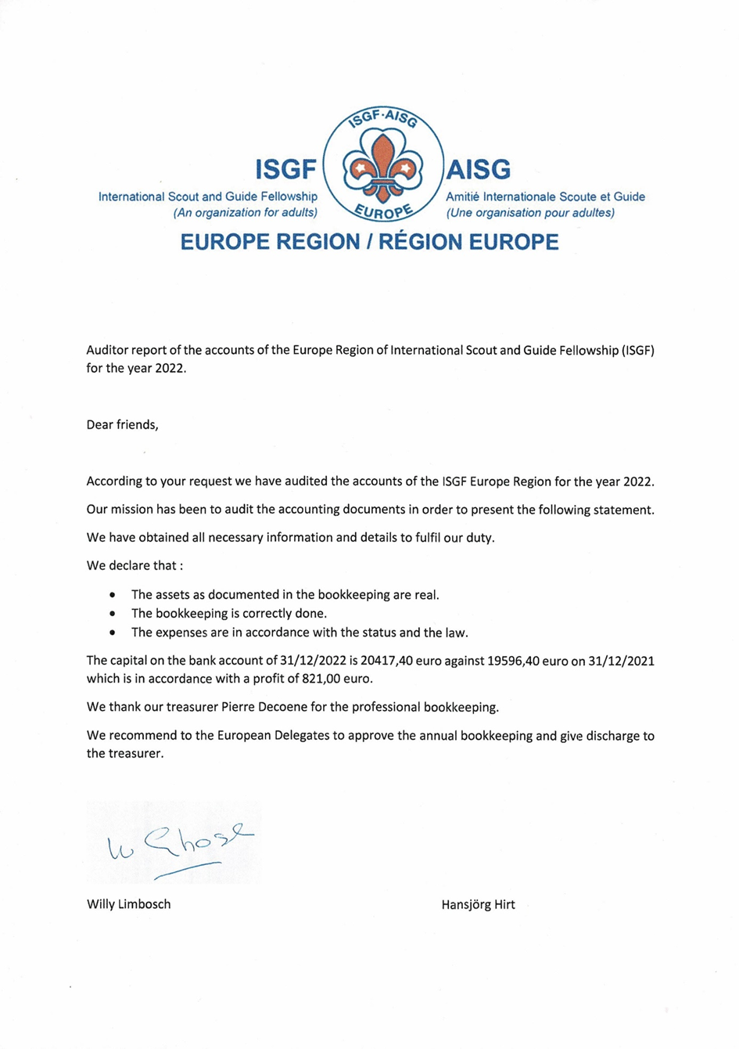

Van: Greenmail <hansjoerg.hirt@greenmail.ch>
Verzonden: zondag 29 januari 2023 16:11
Aan: Pierre Decoene <Pierre.decoene@telenet.be>
Onderwerp: AW: audition

Please find included the documents for auditing the Europe Account.

Audit Report
The Audit Report is OK
Hansjörg Hirt

Gesendet von Mail für Windows

Von: Pierre Decoene
Gesendet: Dienstag, 24. Januar 2023 16:49
An: hansjoerg.hirt@greenmail.ch; Willy (ISGF NL) Limbosch
Betreff: audition

Willy, Hansjörg,

Please find included the documents for auditing the Europe Account.

Pierre Decoene

