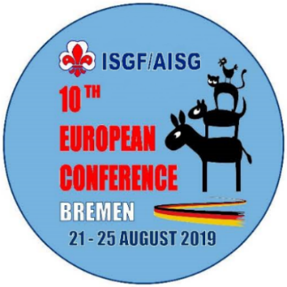
10th Europe Conference
10e Conférence Européenne
Bremen, Germany 21. – 25. August 2019

Document B
Presentations and Exhibition

Dear friends,

We offer the members of the ISGF Europe Region two possibilities to inform about activities and projects of the National Fellowships:
- 1. A movie or a PowerPoint presentation with a max. length of 5 minutes.
- 2. Exhibition area: - a table (free of charge) or a panel (25,00€).

1. Presentation of activities – max. 5 minutes
If you are going to use any audio visual devices you have to hand them over an USB stick or CD or DVD at the beginning of the conference to a member of the conference staff. Please write down name of the NSGF and title of the presentation.

Title of the presentation:

………………………………………………………………………………………………………………………

Presentation on USB stick or CD or DVD (please select)

………………………………………………………………….….

2. We want to have space for an exhibition: a table (free of charge) or a panel (cost 25 Euro)

Which one?

………………………………………………………………………………………………………………………

Name of NSGF – other organization

………………………………………………………………………………………………………………………

Please complete and return this form the 1th May 2019 at the latest

To pierre.decoene@telenet.be

or by mail to
Pierre Decoene
Kortrijksestraat 319
8870 Izegem
Belgium

